Spring Boot Based Application using

* Spring Web – For creating REST based web Service with Embedded Tomcat Server
* Spring Data JPA – To Interact with any RDBMS easily
* Spring Boot Dev Tools – For Automatic Server Restart and Live-reloading when the code changes.
* H2,MySQL, Oracle, Postgres – Support for various Database
* Lombok – To simplify the boiler plate code generation

For Modularity

* Basepackage, model,entity, controller,repo(DAO), service, exception, util,configuration

Composite Primary Key – Making primary key on two or more column is called Composite Primary Key.

Micro Service –

Online Application (Flipkart/Amazon)

* Product Service
* User Service
* Payment Service (COD/EMI/UPI/Internet Banking)
* Rating Service
* Comment Service
* Compare Service
* Shipment Service
* Offer Service

Monolith Application - All the services work from a Single project. (Spring Boot)

Micro-Service [N number of Spring Boot Application – Each Spring Boot application for a Specific Service]

Micro-Service – It’s a way/style in developing loosely coupled (de-coupled) enterprise service based applications.

 Micro-Service is an architectural style that structures an application as a collection of services.

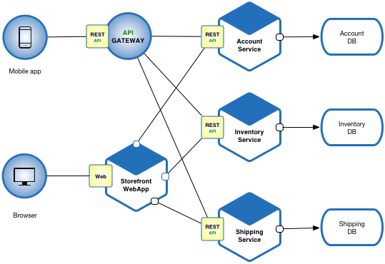

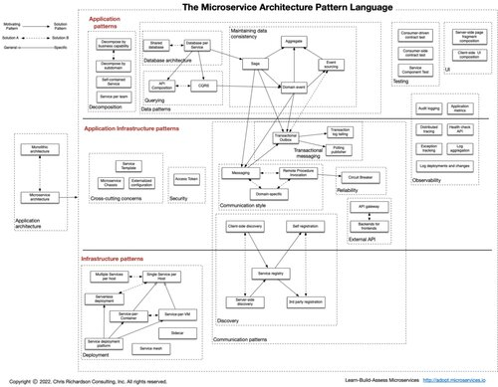

Types of Web Applications

- Static Web (Can be developed using just HTML/CSS/JS) – Content will not change wrt user/time/location (Temple websites/ some blogs on some places/persons)

- Dynamic Web (Contents changes with respect to users/time/location )

* Physical Address – DoorNo/Street Name/Area/City/Pincode/State (Mobile)
* IP Address – Internet Protocol (IPv4,IPv6)

Discovery Service – API Gateway – Registry Service

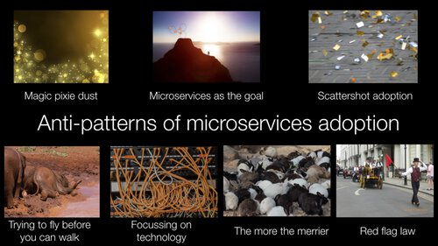

Netflix OSS = Netflix Open Source Software

<https://www.codercrunch.com/topic/921904944/netflix-architecture>

* Netflix/Hystrix: Hystrix is a latency and fault tolerance library designed to isolate points of access to remote systems, services
* Netflix/eureka : AWS Service registry for resilient mid-tier load balancing and failover.
* Netflix/zuul : Zuul is a gateway service that provides dynamic routing, monitoring, resiliency, security, and more.
* Netflix/SimianArmy : Tools for keeping your cloud operating in top form. Chaos Monkey is a resiliency tool that helps applications tolerate random instance failures.
* Netflix/ribbon : Ribbon is a Inter-Process Communication (remote procedure calls) library with built-in software load balancers. The primary usage model involves REST calls with various serialization scheme support.
* Netflix/falcor : A JavaScript library for efficient data fetching.

<https://spring.io/guides/gs/service-registration-and-discovery/>

Steps in Creating Micro-Service

1. Create Eureka Server (Discovery/Registry/Gate-way Service)
   1. Open STS, Create a new Spring Starter Project, add Spring Web, Dev Tools & Eureka Server dependencies.
   2. Add the following properties in application.properties

server.port=8761

eureka.client.register-with-eureka=false

eureka.client.fetch-registry=false

logging.level.com.netflix.eureka=OFF

logging.level.com.netflix.discovery=OFF

* 1. Add @EnableEurekaServer Annotation in Starter class
  2. Run the application & Open localhost:8761
* 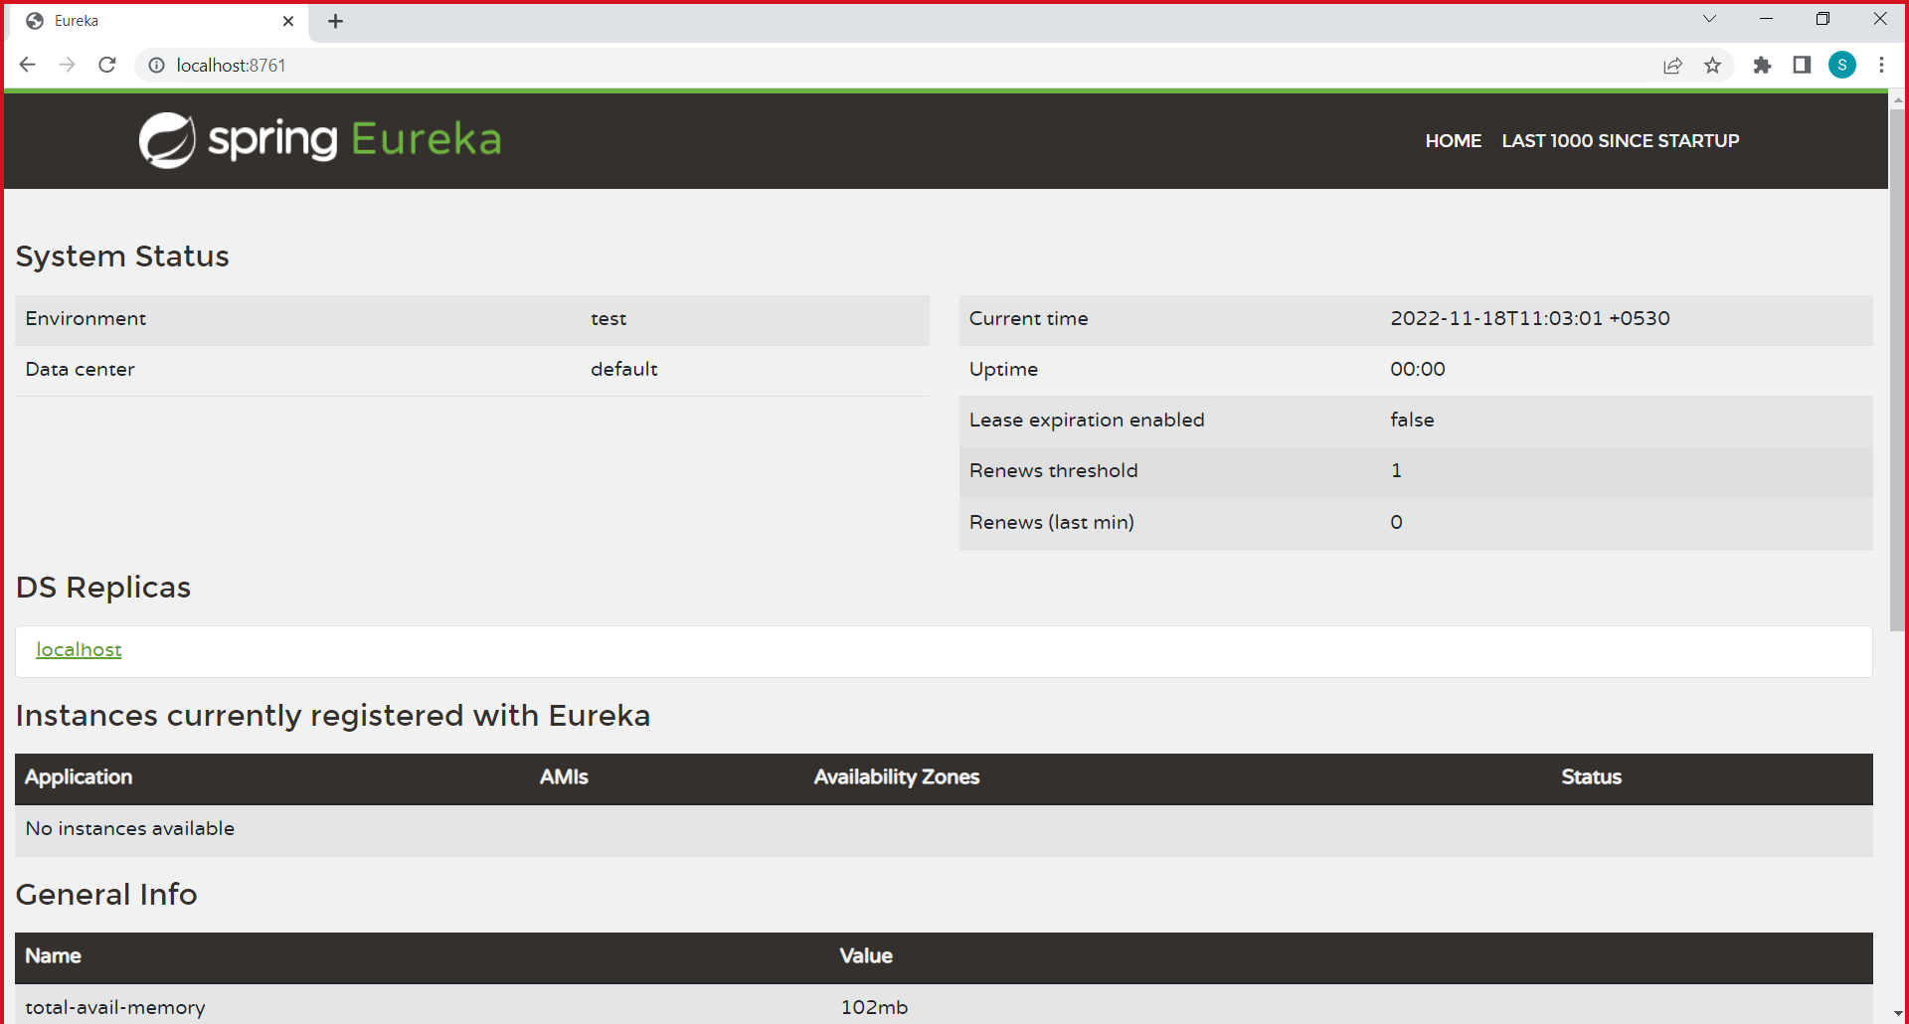

Eureka Discovery Server /Eureka Registry Server/Eureka Gateway Server/ API-Gateway Server

1. Create few micro-service Applications
   1. Create a new Spring Starter Project with following dependencies
      1. Spring Web
      2. Spring Boot Dev Tools
      3. Spring Data JPA
      4. Lombok
      5. H2 Database
      6. MySQL Database Driver
      7. Postgres Driver
      8. Eureka Discovery Client
   2. Add @EurekaEurekaClient annotation in the Starter class
   3. Add the following properties in application.properties file

server.port=8085

spring.application.name=product-service